SOP for Incidents Analysis by L1

SOP1: Database Connectivity:
BRM DB
Host/IP | 172.20.14.25
Port | 1521
Service Name | PRDBRMPDB.itc.local
Username | MS_L1
Password | Tiger#4321#tiger

BRM DB:
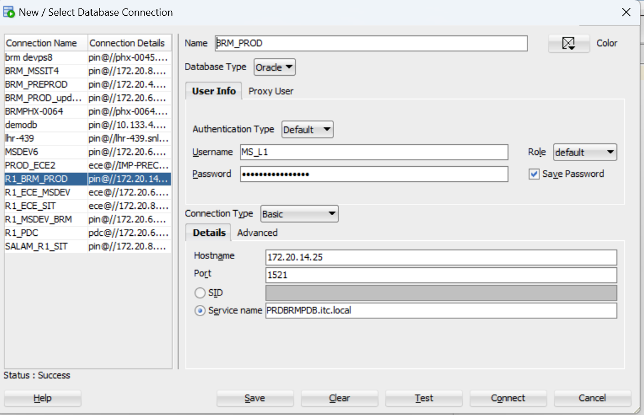

SOP2: Check if MSISDN is present in DB or not Initial Validation
Check if MSISDN is present in DB or not
select login,s.* from pin.service_t s where login like '%966510486933%';
select * from pin.service_alias_list_t where name like '%966510486933%';

If MSISDN not present, assign it back to requestor and ask them to check with Optiva
If present, assign it to BRM team.

SOP3: Query Service or MSISDN

To check the Service Status
sa.name is the input for the query. MSISDN need pass as input

select a.account_no SA_ACCOUNT_NO,a.poid_id0 SA_Acc_poid,a.aac_access,
case
when access_code1 is NULL then 'B2B_Postpaid'
Else access_code1
END as "ACC_TYPE",
sa.name MSISDN,s.login,s.poid_id0 Service_Poid,
s.bal_grp_obj_id0,s.status,
Case
when s.status =10100 then 'Active'
when s.status =10102 then 'Suspend'
when s.status =10103 then 'Inactive'
Else 'Others'
END as "SERVICE_STATUS",
s.lifecycle_state,cl.state_name LIFECYCLE_STATE1,
TO_CHAR(FROM_TZ(TO_TIMESTAMP('1970-01-01', 'YYYY-MM-DD') + NUMTODSINTERVAL(s.created_t, 'SECOND'), 'GMT') AT TIME ZONE 'Asia/Riyadh', 'DD-MM-YYYY HH24:MI:SS') AS created_t,
TO_CHAR(FROM_TZ(TO_TIMESTAMP('1970-01-01', 'YYYY-MM-DD') + NUMTODSINTERVAL(s.state_expiration_t, 'SECOND'), 'GMT') AT TIME ZONE 'Asia/Riyadh', 'DD-MM-YYYY HH24:MI:SS') AS state_expireation
from pin.account_t a ,pin.service_t s,pin.service_alias_list_t sa,pin.config_lifecycle_states_t cl
where s.poid_id0=sa.obj_id0
and cl.state_id=s.lifecycle_state
and s.account_obj_id0 =a.poid_id0
and sa.name in ('966511705451','966511600578','966510728694');

LIFECYCLE_STATE1 need to verify.
Status | Description
Active | Service in Active state. Able to use all the services
CL Breach/ Credit Limit Breach | Customer Breached his currency limit. He can able to use the services from his monthly buckets. But PAYG services not able to use (Means consumes from Currency bucket)
OG Bar/OG-Barred | Outgoing Services will be stopped. Incoming will work like incoming calls.
Full Bar | Both outgoing and incoming services will not work
Suspended | All the Services was stopped.
Terminated | Cancelled the service

SOP4: Query Check The Products under customer.

To check the which plan customer having and status of plan. Pass the 3.1 Query “SA_Acc_poid” filed as input to “pp.account_obj_id0”
select p.name,pp.status,
Case
when pp.status =1 then 'Active'
when pp.status =2 then 'Suspend'
when pp.status =3 then 'Inactive'
Else 'Others'
END as "PRODUCT_STATUS",
pp.cycle_fee_amt,pp.poid_type,pp.poid_id0 renew_product_poid,
pp.account_obj_id0,
TO_CHAR(FROM_TZ(TO_TIMESTAMP('1970-01-01', 'YYYY-MM-DD') + NUMTODSINTERVAL(pp.created_t, 'SECOND'), 'GMT') AT TIME ZONE 'Asia/Riyadh', 'DD-MM-YYYY HH24:MI:SS') AS created_t,
TO_CHAR(FROM_TZ(TO_TIMESTAMP('1970-01-01', 'YYYY-MM-DD') + NUMTODSINTERVAL(pp.cycle_start_t, 'SECOND'), 'GMT') AT TIME ZONE 'Asia/Riyadh', 'DD-MM-YYYY HH24:MI:SS') AS cycle_start_t,
TO_CHAR(FROM_TZ(TO_TIMESTAMP('1970-01-01', 'YYYY-MM-DD') + NUMTODSINTERVAL(pp.cycle_end_t, 'SECOND'), 'GMT') AT TIME ZONE 'Asia/Riyadh', 'DD-MM-YYYY HH24:MI:SS') AS cycle_end_t
from pin.purchased_product_t pp,pin.product_t p where
pp.product_obj_id0=p.poid_id0 and
pp.cycle_fee_amt<>0 and
pp.account_obj_id0 in ('93866938872')
order by pp.account_obj_id0;

At least one product should be in active state with cycle_state_t is past date and cycle_end_t should be future date or 0 (01-01-1970).
If no active product, then check with CRM any disconnect/Modify order. Share the details with BRM team.

SOP5: Query Renewal Check
To check the Last renewal date and next renewal dates. Pass the 3.2 Query “renew_product_poid” filed as input to “pp.poid_id0”
select pp.poid_type,pp.poid_id0,pp.status,
Case
when pp.status =1 then 'Active'
when pp.status =3 then 'Inactive'
Else 'Others'
END as "PRODUCT_STATUS",
TO_CHAR(FROM_TZ(TO_TIMESTAMP('1970-01-01', 'YYYY-MM-DD') + NUMTODSINTERVAL(pc.charged_from_t, 'SECOND'), 'GMT') AT TIME ZONE 'Asia/Riyadh', 'DD-MM-YYYY HH24:MI:SS') AS Last_Renewal,
TO_CHAR(FROM_TZ(TO_TIMESTAMP('1970-01-01', 'YYYY-MM-DD') + NUMTODSINTERVAL(pc.charged_to_t, 'SECOND'), 'GMT') AT TIME ZONE 'Asia/Riyadh', 'DD-MM-YYYY HH24:MI:SS') AS Next_Renewal,
TO_CHAR(FROM_TZ(TO_TIMESTAMP('1970-01-01', 'YYYY-MM-DD') + NUMTODSINTERVAL(pc.cycle_fee_start_t, 'SECOND'), 'GMT') AT TIME ZONE 'Asia/Riyadh', 'DD-MM-YYYY HH24:MI:SS') AS cycle_fee_start_t,
TO_CHAR(FROM_TZ(TO_TIMESTAMP('1970-01-01', 'YYYY-MM-DD') + NUMTODSINTERVAL(pc.cycle_fee_end_t, 'SECOND'), 'GMT') AT TIME ZONE 'Asia/Riyadh', 'DD-MM-YYYY HH24:MI:SS') AS cycle_fee_end_t
from pin.PURCHASED_PRODUCT_CYCLE_FEES_T pc,
pin.purchased_product_t pp
where pc.obj_id0=pp.poid_id0
and pp.poid_id0 in (9242505747);

SOP6: Query Validate Non Currency Balances

To check the Future dated Non-Currency balance bukcets.
Pass the 3.1 Query “SA_Acc_poid” filed as input to “bb.account_obj_id0”
select bb.account_obj_id0,c.obj_id0,c.rec_id2,cbd.symbol,c.rec_id,cbd.name,TO_CHAR(FROM_TZ(TO_TIMESTAMP('1970-01-01', 'YYYY-MM-DD') + NUMTODSINTERVAL(c.valid_from, 'SECOND'), 'GMT') AT TIME ZONE 'Asia/Riyadh', 'DD-MM-YYYY HH24:MI:SS') AS valid_from_KSA,
TO_CHAR(FROM_TZ(TO_TIMESTAMP('1970-01-01', 'YYYY-MM-DD') + NUMTODSINTERVAL(c.valid_to, 'SECOND'), 'GMT') AT TIME ZONE 'Asia/Riyadh', 'DD-MM-YYYY HH24:MI:SS') AS valid_to_KSA,
TO_CHAR(Current_bal) current_bal, c.granted_bal
,grantor_obj_id0
from pin.bal_grp_sub_bals_t c,pin.bal_grp_t bb , pin.CONFIG_BEID_BALANCES_T cbd
where c.obj_id0 = bb.poid_id0 and bb.account_obj_id0 in (9197755355) and cbd.rec_id = c.rec_id2
and c.valid_to > (select 86400 * (SELECT trunc(sysdate+1)-TO_date('01/01/1970', 'dd/mm/yyyy') DAYS FROM DUAL)-10800 timestamp from dual)
order by bb.account_obj_id0,rec_id2,valid_from asc;

We will get output here if we have grants validity greater than current date
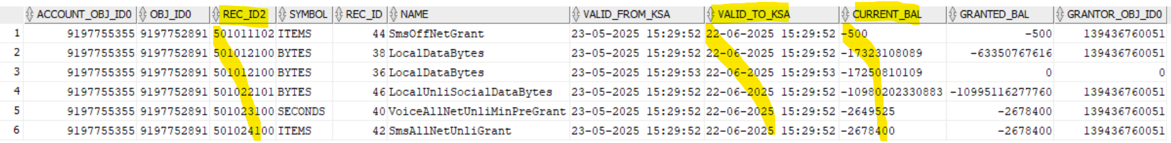

Query: Validate Currency balance
To check the Currency balance buckets.
Pass the 3.1 Query “SA_Acc_poid” filed as input to “bb.account_obj_id0”
select c.obj_id0,c.rec_id2,cbd.symbol,c.rec_id,cbd.name,TO_CHAR(FROM_TZ(TO_TIMESTAMP('1970-01-01', 'YYYY-MM-DD') + NUMTODSINTERVAL(c.valid_from, 'SECOND'), 'GMT') AT TIME ZONE 'Asia/Riyadh', 'DD-MM-YYYY HH24:MI:SS') AS valid_from_KSA,
TO_CHAR(FROM_TZ(TO_TIMESTAMP('1970-01-01', 'YYYY-MM-DD') + NUMTODSINTERVAL(c.valid_to, 'SECOND'), 'GMT') AT TIME ZONE 'Asia/Riyadh', 'DD-MM-YYYY HH24:MI:SS') AS valid_to_KSA,
TO_CHAR(Current_bal) Current_bal, TO_CHAR(FROM_TZ(TO_TIMESTAMP('1970-01-01', 'YYYY-MM-DD') + NUMTODSINTERVAL(bb.effective_t, 'SECOND'), 'GMT') AT TIME ZONE 'Asia/Riyadh', 'DD-MM-YYYY HH24:MI:SS') AS effective_t
from pin.bal_grp_sub_bals_t c,pin.bal_grp_t bb , pin.CONFIG_BEID_BALANCES_T cbd
where c.obj_id0 = bb.poid_id0 and bb.account_obj_id0 in (9175406319) and cbd.rec_id = c.rec_id2
and rec_id2=682
order by rec_id2,valid_from asc;

Current_Bal filed we need to consider.

For Prepaid customer, Current balance should be 0 or < 0 (-Ve value) (If it is in positive we need to fix. Customer won’t be able to use services)
For Postpaid Customer, Current balance will 0 or > 0 (Positive) (If access payment, then it can be in Negative (-ve). Won’t create any issue)

SOP8: Call Usage check (All type of Voice) (Latest Usage occurance)

Take the Acc_poid from 3.1 Query and the give input for et.account_obj_id0

select account_obj_id0,impact_category,
TO_CHAR(FROM_TZ(TO_TIMESTAMP('1970-01-01', 'YYYY-MM-DD') + NUMTODSINTERVAL(created_t, 'SECOND'), 'GMT') AT TIME ZONE 'Asia/Riyadh', 'DD-MM-YYYY HH24:MI:SS') AS created_t
from (
select et.account_obj_id0,ebi.impact_category,max(et.created_t) created_t
from pin.event_t et,pin.event_bal_impacts_t ebi,pin.EVENT_DLAY_SESS_TLCS_T es
where et.poid_id0=ebi.obj_id0
and et.account_obj_id0 in (5055184021)
and et.poid_type='/event/delayed/session/telco/gsm/voice'
and ebi.impact_category in ('Onnet call','Offnet call','Incoming Call')
and et.poid_id0=es.obj_id0
group by et.account_obj_id0,ebi.impact_category);

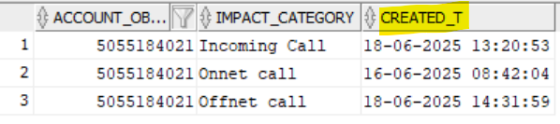

SOP9: Query Data or GPRS usages (Latest Usage occurance)
MSISDN need to pass as input for Login

select account_obj_id0,impact_category,
TO_CHAR(FROM_TZ(TO_TIMESTAMP('1970-01-01', 'YYYY-MM-DD') + NUMTODSINTERVAL(created_t, 'SECOND'), 'GMT') AT TIME ZONE 'Asia/Riyadh', 'DD-MM-YYYY HH24:MI:SS') AS created_t
from (
select et.account_obj_id0,ebi.impact_category,max(et.created_t) created_t
from pin.event_t et,pin.event_bal_impacts_t ebi,pin.EVENT_DLAY_SESS_TLCS_T es
where et.poid_id0=ebi.obj_id0
and et.account_obj_id0 in
(select account_obj_id0 from pin.service_t where login in('966831026009441'))
and et.poid_type like '%gprs%'
-- and ebi.impact_category in ('Onnet call','Offnet call','Incoming Call')
and et.poid_id0=es.obj_id0
group by et.account_obj_id0,ebi.impact_category);

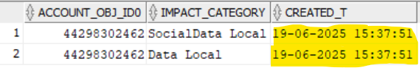

SOP10: Query All Data and Voice usages
MSISDN need to pass as input for Login

select e.account_obj_id0,substr(e.POID_TYPE,0,length(e.POID_TYPE)) UsageType,eb.IMPACT_CATEGORY,
TO_CHAR(FROM_TZ(TO_TIMESTAMP('1970-01-01', 'YYYY-MM-DD') + NUMTODSINTERVAL(e.START_T, 'SECOND'), 'GMT') AT TIME ZONE 'Asia/Riyadh', 'DD-MM-YYYY HH24:MI:SS') AS start_t,
TO_CHAR(FROM_TZ(TO_TIMESTAMP('1970-01-01', 'YYYY-MM-DD') + NUMTODSINTERVAL(e.end_T, 'SECOND'), 'GMT') AT TIME ZONE 'Asia/Riyadh', 'DD-MM-YYYY HH24:MI:SS') AS end_t,
z.calling_from,z.called_to,
decode(substr(e.POID_TYPE,34,length(e.POID_TYPE)),'sms',1,(e.end_t-e.START_T)) as Act_Duration,
eb.QUANTITY,eb.AMOUNT, res.name as resource_name,res.rec_id as Resource_Id,p.name, e.invoice_data, e.SYS_DESCR as Event_type, gl_id--,e.*
From pin.event_t e, pin.event_bal_impacts_t eb,pin.event_dlay_sess_tlcs_t z ,pin.config_beid_balances_t res ,pin.product_t p
Where e.ACCOUNT_OBJ_ID0 in(select account_obj_id0 from pin.service_t where login in ('966511732873'))
and res.rec_id=eb.resource_id and e.POID_ID0=eb.OBJ_ID0 and eb.product_obj_id0=p.poid_id0
and e.POID_ID0=z.OBJ_ID0(+) Order by e.start_T desc;

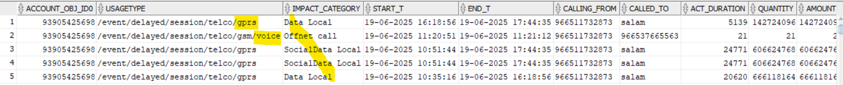

SOP11: Query Au_Service (To check the Audit of the service)
Pass the MSISDN as input for the query. Refer Created_t and Lifecycle state.
select s.au_parent_obj_id0,sa.name,s.poid_type,s.poid_id0,s.status,
Case
when s.status =10100 then 'Active'
when s.status =10102 then 'Suspend'
when s.status =10103 then 'Inactive'
Else 'Others'
END as "SERVICE_STATUS",
lifecycle_state,cl.state_name LIFECYCLE_STATE1,
TO_CHAR(FROM_TZ(TO_TIMESTAMP('1970-01-01', 'YYYY-MM-DD') + NUMTODSINTERVAL(s.created_t, 'SECOND'), 'GMT') AT TIME ZONE 'Asia/Riyadh', 'DD-MM-YYYY HH24:MI:SS') AS created_t,
TO_CHAR(FROM_TZ(TO_TIMESTAMP('1970-01-01', 'YYYY-MM-DD') + NUMTODSINTERVAL(s.state_expiration_t, 'SECOND'), 'GMT') AT TIME ZONE 'Asia/Riyadh', 'DD-MM-YYYY HH24:MI:SS') AS state_expiration_t,
TO_CHAR(FROM_TZ(TO_TIMESTAMP('1970-01-01', 'YYYY-MM-DD') + NUMTODSINTERVAL(s.mod_t, 'SECOND'), 'GMT') AT TIME ZONE 'Asia/Riyadh', 'DD-MM-YYYY HH24:MI:SS') AS mod_t,
TO_CHAR(FROM_TZ(TO_TIMESTAMP('1970-01-01', 'YYYY-MM-DD') + NUMTODSINTERVAL(s.last_status_t, 'SECOND'), 'GMT') AT TIME ZONE 'Asia/Riyadh', 'DD-MM-YYYY HH24:MI:SS') AS last_status_t
from pin.au_service_t s,pin.au_service_alias_list_t sa,pin.config_lifecycle_states_t cl
where s.poid_id0=sa.obj_id0
and cl.state_id=s.lifecycle_state
and sa.name in ('966511623810')
--and s.au_parent_obj_id0 in ('44295950867')
order by s.created_t desc;

Latest created is the updated status.

SOP12: how To Connect to Testnap (CM-Batch)
- Connect to BRM Server
Server : 172.20.2.40
User Name : opc
Password : Shared internally with L1

Please refer below screenshot
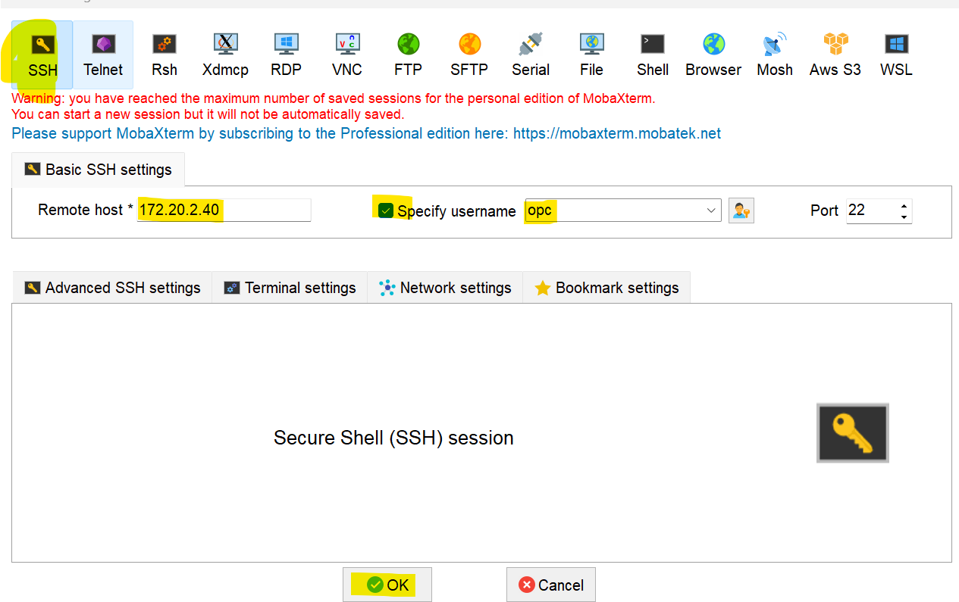
- Enter the Password. You will be logged to BRM server.
- Please follow below steps
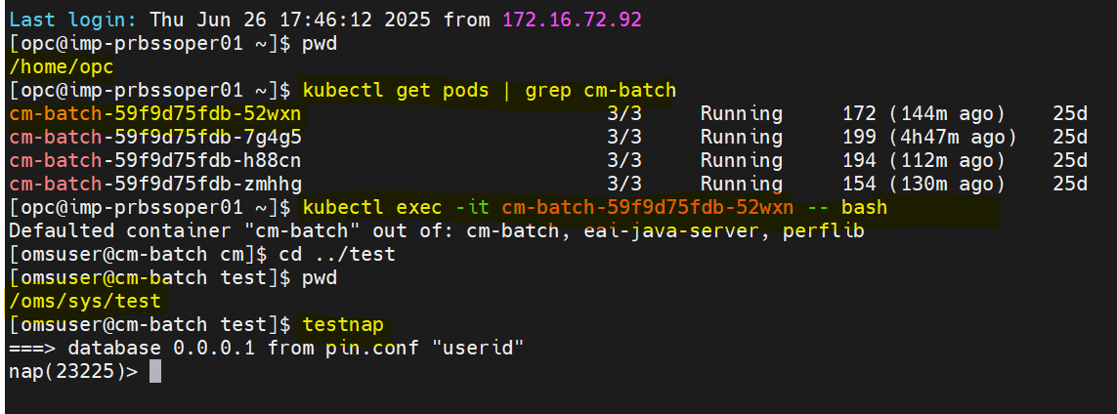

Command: kubectl get pods | grep cm-batch

Taka the first pod. Example: cm-batch-59f9d75fdb-52wxn
Note: Pod name will change if cm-batch restart happens.

- Connecting to cm-batch pod and connecting to testnap utility
Command1: kubectl exec -it cm-batch-59f9d75fdb-52wxn – bash
Command2: cd /oms/sys/test
Command3: testnap

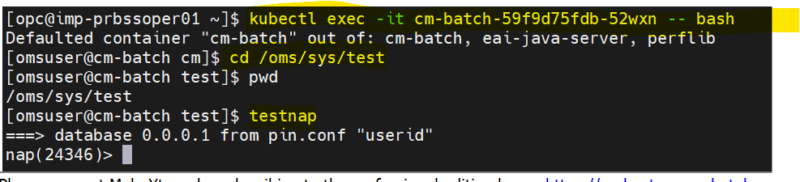

SOP12: how to get ECE Balance
Get Service_Poid and MSISDN from query 3.1

Input Flist:
r << 1 1
0 PIN_FLD_POID POID [0] 0.0.0.1 /service/telco/gsm 44270019340
0 PIN_FLD_LOGIN STR [0] "966511705451"
0 PIN_FLD_MODE ENUM [0] 0
1
xop PCM_OP_BAL_GET_ECE_BALANCES 0 1

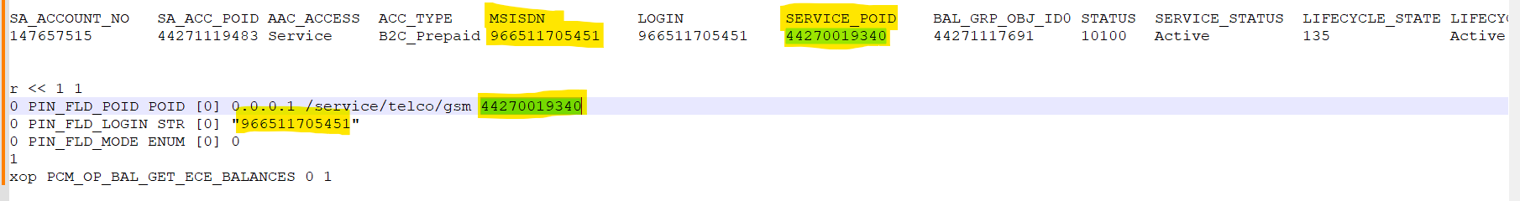

Output:
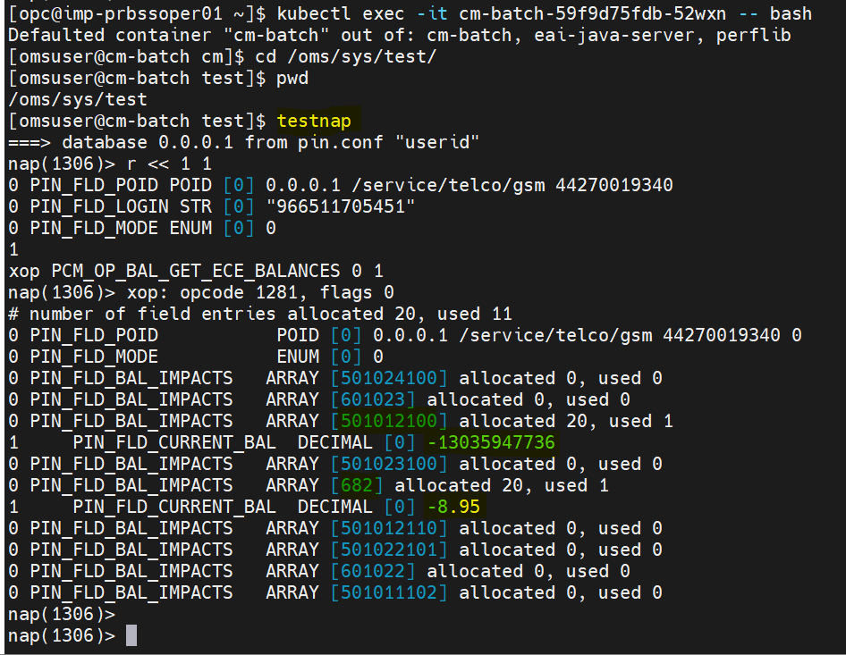

SOP14: how To Check Diameter error
1) Connect to BRM Server
Server : 172.20.2.40
User Name : opc
Password : Shared internally with L1

Please refer below screenshot
Enter the Password. You will be logged to BRM server.
Please follow below steps
Path: cd /mnt/PRDBSS/prd-brm-apps-logs-pvc-pvc-75fb89e0-e243-4147-bcb2-1c510fb853a5/

Command: grep -i "966509560262" dia*.log*
MSISDN need to pass here.

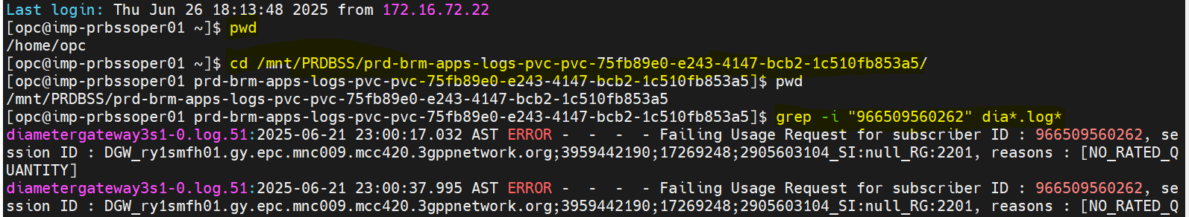

If you see any error like above. Assign to BRM to check.

If no error or nothing which means no diameter failures.

SOP15: How To Check payment event
To check the latest payment received.
select e.account_obj_id0,
TO_CHAR(FROM_TZ(TO_TIMESTAMP('1970-01-01', 'YYYY-MM-DD') + NUMTODSINTERVAL(e.created_t, 'SECOND'), 'GMT') AT TIME ZONE 'Asia/Riyadh', 'DD-MM-YYYY HH24:MI:SS') AS created_t,
e.poid_type,eb.amount,due,resource_id,e.sys_descr,e.program_name,descr
from pin.event_t e, pin.event_bal_impacts_t eb,pin.item_t i
where e.poid_id0=eb.obj_id0
and e.item_obj_id0=i.poid_id0
and eb.resource_id =682
and amount<>0
and i.poid_type in ('/item/payment')
and eb.account_obj_id0 in (118012975066 )
order by eb.account_obj_id0,e.created_t desc;

Sop16: How to check Call Drop
(Call drop /Call Failure/ Incoming call)

Check the MSISDN Status and Life cycle state. Refer query 3.1

Audit Service - Check the MSISDN audit Status and Life cycle state. Refer query 3.9

Check the voice usage. Refer query 3.6
If latest voice usage, then resolve the ticket.
If not, please check the balances. Refer query 3.4

Check the balances from BRM. Refer query 3.4

Check the balances from ECE. Refer query 3.10 and 3.11

Compare both BRM ECE balances. Please find below screenshot
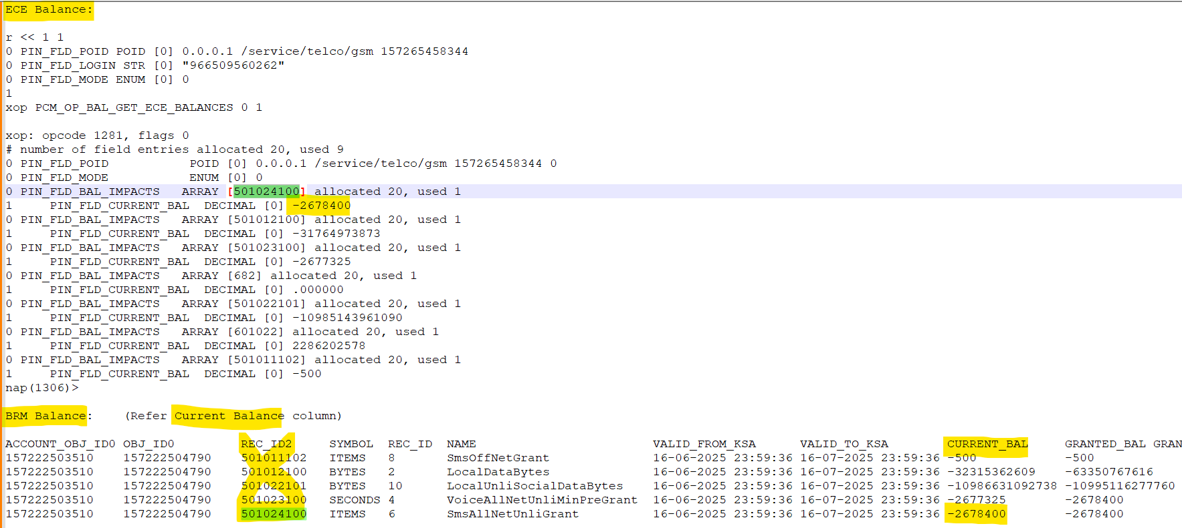
ECE balance and BRM should be equal or almost same. (Minor difference can be expected because ECE is real time)

If everything okay, then check the diameter errors. Refer 3.11
If no diameter errors found, then assign the ticket to check from ASAP whether all the profile okay or not? If ASAP already validated, then Assigned to Core network to check.

SOP17: Social media dedicated from Data
Local data :501012100
Social data:501022101

USAGE_CLASS='2030' – Social Data

Check the MSISDN Status and Life cycle state. Refer query 3.1

Validating social media dedicated from Data or not.

Take the SA_Acc_poid from query 3.1 and the give input for et.account_obj_id0

select es.CALLING_FROM,es.CALLED_TO,ebi.impact_category,et.poid_id0,et.poid_type,et.network_session_id,
TO_CHAR(FROM_TZ(TO_TIMESTAMP('1970-01-01', 'YYYY-MM-DD') + NUMTODSINTERVAL(et.created_t, 'SECOND'), 'GMT') AT TIME ZONE 'Asia/Riyadh', 'DD-MM-YYYY HH24:MI:SS') AS created_t,
TO_CHAR(FROM_TZ(TO_TIMESTAMP('1970-01-01', 'YYYY-MM-DD') + NUMTODSINTERVAL(et.earned_start_t, 'SECOND'), 'GMT') AT TIME ZONE 'Asia/Riyadh', 'DD-MM-YYYY HH24:MI:SS') AS earned_start_t,
TO_CHAR(FROM_TZ(TO_TIMESTAMP('1970-01-01', 'YYYY-MM-DD') + NUMTODSINTERVAL(et.earned_end_t, 'SECOND'), 'GMT') AT TIME ZONE 'Asia/Riyadh', 'DD-MM-YYYY HH24:MI:SS') AS earned_end_t,
ebi.amount,ebi.quantity,ebi.impact_type,
ebi.resource_id,ebi.product_obj_id0,ebi.offering_obj_id0,et.poid_type,et.created_t
from pin.event_t et,pin.event_bal_impacts_t ebi,pin.EVENT_DLAY_SESS_TLCS_T es where et.poid_id0=ebi.obj_id0
and et.account_obj_id0=21372709121
and et.poid_id0=es.obj_id0
and ebi.resource_id = ('501012100')
and es.USAGE_CLASS='2030'
order by et.created_t desc;

If no entries, then we can assign back to requester with below comment.
“We have validated from BSS, Social data consumed form Social data bucket not from Data local Whatever we are receiving from network it is charging correctly. If any concern check with core network team.”

If you see any entries, then assign to BRM.

Sop18: Renewal Issue

Check the MSISDN Status and Life cycle state. Refer query 3.1

Check the Renewal Product. Refer query 3.2

Renewal Check. Refer query 3.3

Case1
If the Next_renewal is future date then renewal was done. Just validate the balances.
(Valid_from Should be same date as Last_Renewal and Valid_to should be same date as Next_Renewal )

Check the balances from BRM. Refer query 3.4

Check the balances from ECE. Refer query 3.10 and 3.11

Compare both BRM ECE balances. Please find below screenshot
ECE balance and BRM should be equal or almost same. (Minor difference can be expected because ECE is real time)

If matching, then resolve the ticket saying grants applied.

Case2
If the Next_renewal is less than current date then validate the Currency balance (Current_Bal(it will be in -Ve) should be granter than cycle_fee_amt)

Check the balances from BRM. Refer query 3.5

Check the balances from ECE. Refer query 3.10 and 3.11

Compare both BRM ECE balances for currency resource (682. Please find below screenshot
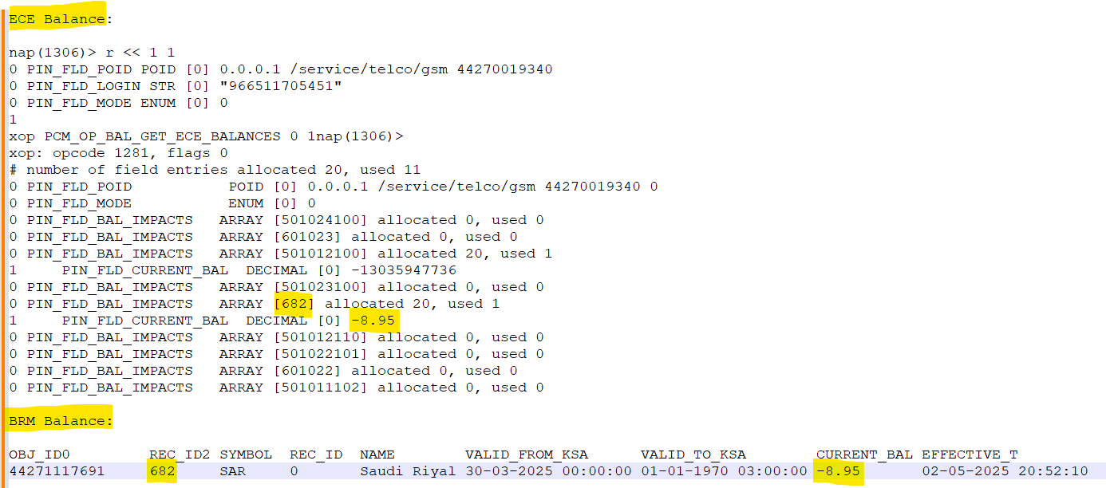
ECE balance and BRM should be equal or almost same. (Minor difference can be expected because ECE is real time).
Note: It will depend on ECE Balance
Example: If cycle_fee_amt is 99 then Current bal should be -99 or less.

If you sum up of current balance and product charge it should be equal or less than 0.

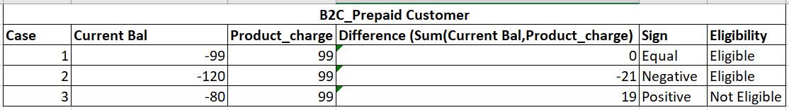

If Eligible, then assign to BRM.

If Not Eligible, then assign the ticket back to user saying “No sufficient balances for renewal. Please check”

Billing Dispute
Sub Cat: Billing Dispute, Compensation and Complaint
- If anything, related invoice and bill then assign to BRM
- If anything related to Compensations, then check with respective person like Khalid and take actions. Compensations handling from CRM.

Service benefits not applied

Check when the service created, and Incident created. If is same time, then check below.

Check the MSISDN Status and Life cycle state. Refer query 3.1

Check the Renewal Product. Refer query 3.2

Renewal Check. Refer query 3.3

Case1

If the Next_renewal is future date then renewal was done. Just validate the balances.
(Valid_from Should be same date as Last_Renewal and Valid_to should be same date as Next_Renewal )

Check the balances from BRM. Refer query 3.4

Check the balances from ECE. Refer query 3.10 and 3.11

Compare both BRM ECE balances. Please find below screenshot

ECE balance and BRM should be equal or almost same. (Minor difference can be expected because ECE is real time)

If matching, then resolve the ticket.
Resolve the ticket with comment “Service benefits applied. Balances are present. Please check”

Case2
If the Next_renewal is less than current date then validate the Currency balance (Current_Bal(it will be in -Ve) should be granter than cycle_fee_amt)

Check the balances from BRM. Refer query 3.5

Check the balances from ECE. Refer query 3.10 and 3.11

Compare both BRM ECE balances for currency resource (682. Please find below screenshot
ECE balance and BRM should be equal or almost same. (Minor difference can be expected because ECE is real time).
Note: It will depend on ECE Balance
Example: If cycle_fee_amt is 99 then Current bal should be -99 or less.

If you sum up of current balance and product charge it should be equal or less than 0.

If Eligible, then assign to BRM.

If Not Eligible, then assign the ticket back to user saying “No sufficient balances for renewal. Please check”

Missing Call Notification (Mawjood)

Check the MSISDN. If is the B2C customer, then assign to ASAP. This need to be checked from ASAP.

No internet

Check the MSISDN Status and Life cycle state. Refer query 3.1
Validate any latest usage on the MSISDN or not. If yes, we can resolve.

Check the data usage. Refer query 3.7
If latest usage, then resolve ticket.
If not, then validate Call Drop issue steps. (Point 4)

Voucher recharge issues
Take the MSISDN and Check for the Serial number given in the incident.
Example:
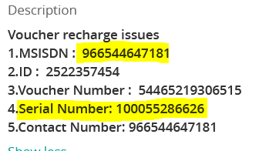

select MSISDN,serial_number,
TO_CHAR(FROM_TZ(TO_TIMESTAMP('1970-01-01', 'YYYY-MM-DD') + NUMTODSINTERVAL(s.created_t, 'SECOND'), 'GMT') AT TIME ZONE 'Asia/Riyadh', 'DD-MM-YYYY HH24:MI:SS') AS created_t,
s.descr,s.receipt_no,s.total_amount,voucher_type,HRN,s.*
from pin.SLM_PYMT_TOPUP_T s
where serial_number is not null
--and serial_number in (100054427336);
and MSISDN ='966544647181';
select * from pin.slm_recharge_history_vw where MSISDN ='966544647181';

If present resolve the incident
“We see Voucher recharge success with given serial_number. Please check
MSISDN SERIAL_NUMBER CT DESCR RECEIPT_NO TOTAL_AMOUNT VOUCHER_TYPE HRN
966544647181 100055286626 30-MAY-25 01:33:37 ussd PYMT25051632723687 100 voucher 54465219306515”

No Signal

Check the Order status and MSISDN status from CRM

Check the Profiles from ASAP

Check the latest usage from BRM. Execute the 3.8 Query
If any latest usage, then resolve ticket. (Impact_category like local data, social data, incoming, on-net and offnet)
If no recent usage, then validate below.
- Service benefits not applied steps
- Call Drop steps.
If no diameter errors found, then assign the ticket to check from ASAP whether all the profile okay or not? If ASAP already validated, then Assigned to Core network to check.

Payment Done but not Reflected (BSS Mails)
Validate the MSISDN.

Assign the ticket to Digital and ask them to check.
If they have payment and Error response, they get from Oracle. Ask them to share the info in below template.
AMOUNT | TRANS_ID | TRANS_METHOD_ID | PROGRAM_NAME | CHANNEL | EXTERNAL_USER | MSISDN | TYPE_STR
If it back to us then validate below.

Check the MSISDN Status and Life cycle state. Refer query 3.1

Check any payment received on mentioned dates or use Trans_id/MSISDN in below query.
select MSISDN,
TO_CHAR(FROM_TZ(TO_TIMESTAMP('1970-01-01', 'YYYY-MM-DD') + NUMTODSINTERVAL(st.created_t, 'SECOND'), 'GMT') AT TIME ZONE 'Asia/Riyadh', 'DD-MM-YYYY HH24:MI:SS') AS created_t,
trans_id,total_amount,recharge_amount,Current_balance,Descr,Bill_no,receipt_no,
st.*
from pin.SLM_PYMT_TOPUP_T st where --trans_id ='d75dddc1-3084-4ab5-b52c-eb48bb836dad';
MSISDN='966599373055';

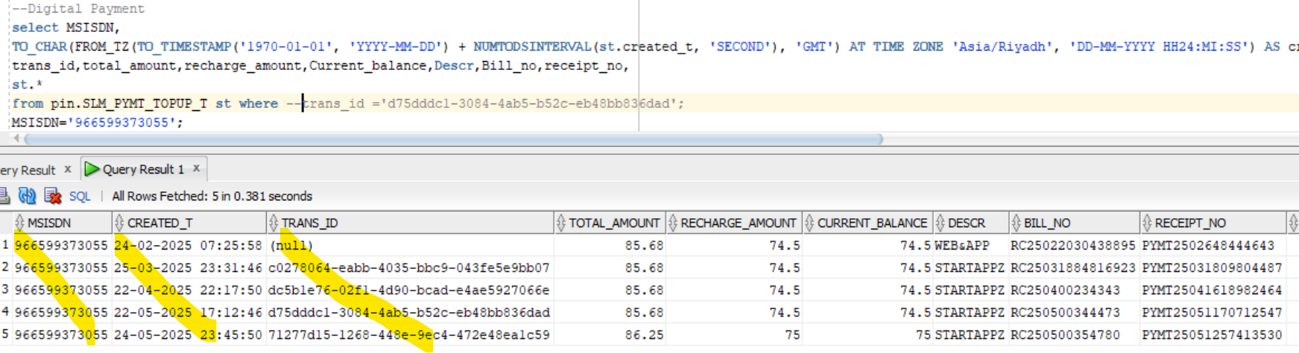
If you have Trans_id in incident, then validate with same.

Case1
If present then, validate BRM ECE balances.

Check the balances from BRM. Refer query 3.5

Check the balances from ECE. Refer query 3.10 and 3.11

Compare both BRM ECE balances for currency resource (682. Please find below screenshot

If Matching resolve the ticket. If the difference more than +1 or -1 then assign to BRM.

Case2
If Trans_id not present, then we need to manually do the payment from BRM.

For Postpaid Customer
Input from Digital
create-account-transaction (Postpaid)
adjustmentType = 50069
transactionMethodID = 5
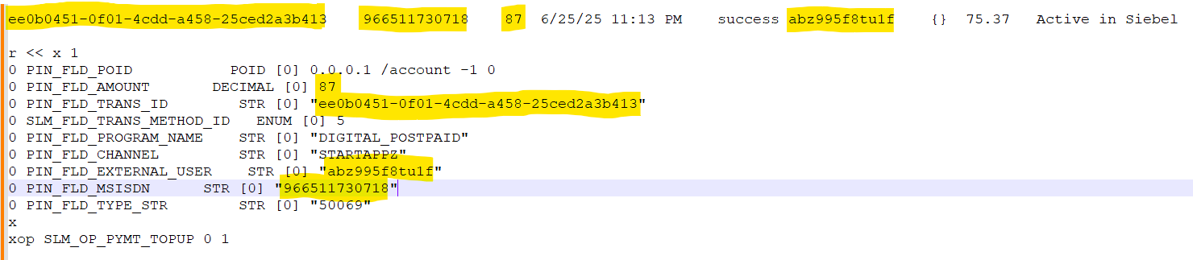
Note: For Post paid customer we need to pass the same amount we got from Digital. Here 87 we passed.
r << x 1
0 PIN_FLD_POID POID [0] 0.0.0.1 /account -1 0
0 PIN_FLD_AMOUNT DECIMAL [0] 87
0 PIN_FLD_TRANS_ID STR [0] "ee0b0451-0f01-4cdd-a458-25ced2a3b413"
0 SLM_FLD_TRANS_METHOD_ID ENUM [0] 5
0 PIN_FLD_PROGRAM_NAME STR [0] "DIGITAL_POSTPAID"
0 PIN_FLD_CHANNEL STR [0] "STARTAPPZ"
0 PIN_FLD_EXTERNAL_USER STR [0] "abz995f8tu1f"
0 PIN_FLD_MSISDN STR [0] "966511730718"
0 PIN_FLD_TYPE_STR STR [0] "50069"
x
xop SLM_OP_PYMT_TOPUP 0 1
Output
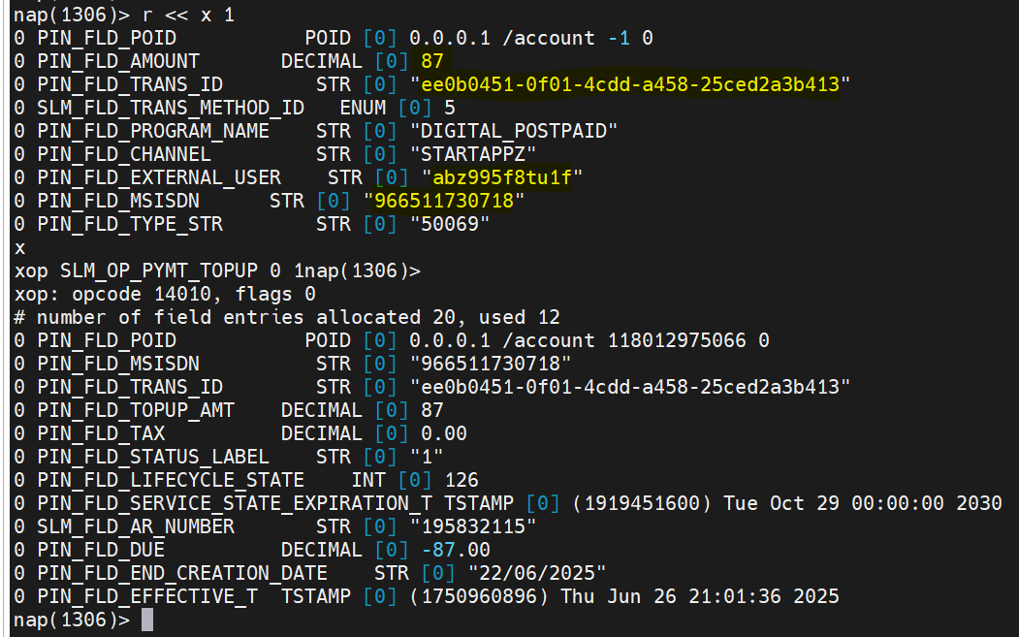
Validate once done.
Query above

For Prepaid Customer
Input from Digital
create-subscription-transaction (Perpaid)
adjustmentType = 32602 / 50284 / 50285 / 50283
transactionMethodID = 5/3
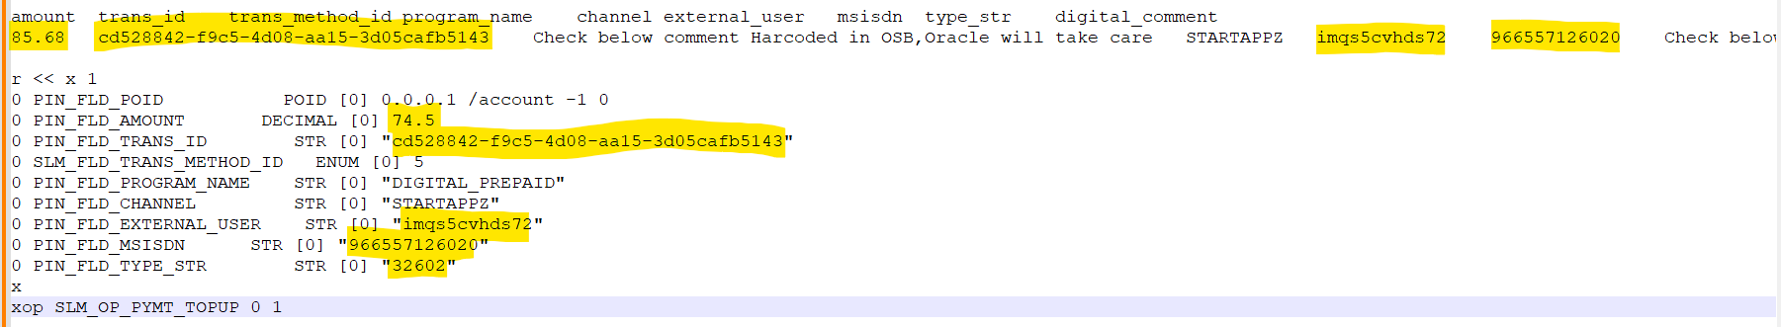

Note: For Pre paid customer we need to pass the amount without tax. Here we got amount as 85.68 (including tax). In the input flist we need to pass without Tax amount (74.5).
Formula: =85.68*100/115 ( Amount will be changed)
r << x 1
0 PIN_FLD_POID POID [0] 0.0.0.1 /account -1 0
0 PIN_FLD_AMOUNT DECIMAL [0] 74.5
0 PIN_FLD_TRANS_ID STR [0] "cd528842-f9c5-4d08-aa15-3d05cafb5143"
0 SLM_FLD_TRANS_METHOD_ID ENUM [0] 5
0 PIN_FLD_PROGRAM_NAME STR [0] "DIGITAL_PREPAID"
0 PIN_FLD_CHANNEL STR [0] "STARTAPPZ"
0 PIN_FLD_EXTERNAL_USER STR [0] "imqs5cvhds72"
0 PIN_FLD_MSISDN STR [0] "966557126020"
0 PIN_FLD_TYPE_STR STR [0] "32602"
x
xop SLM_OP_PYMT_TOPUP 0 1

Validate once done.
Query above

